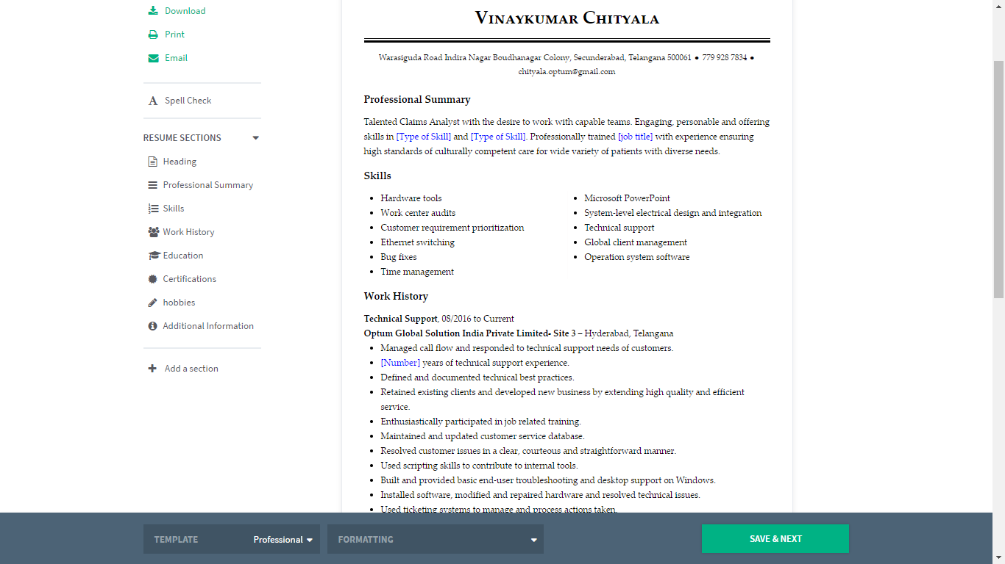

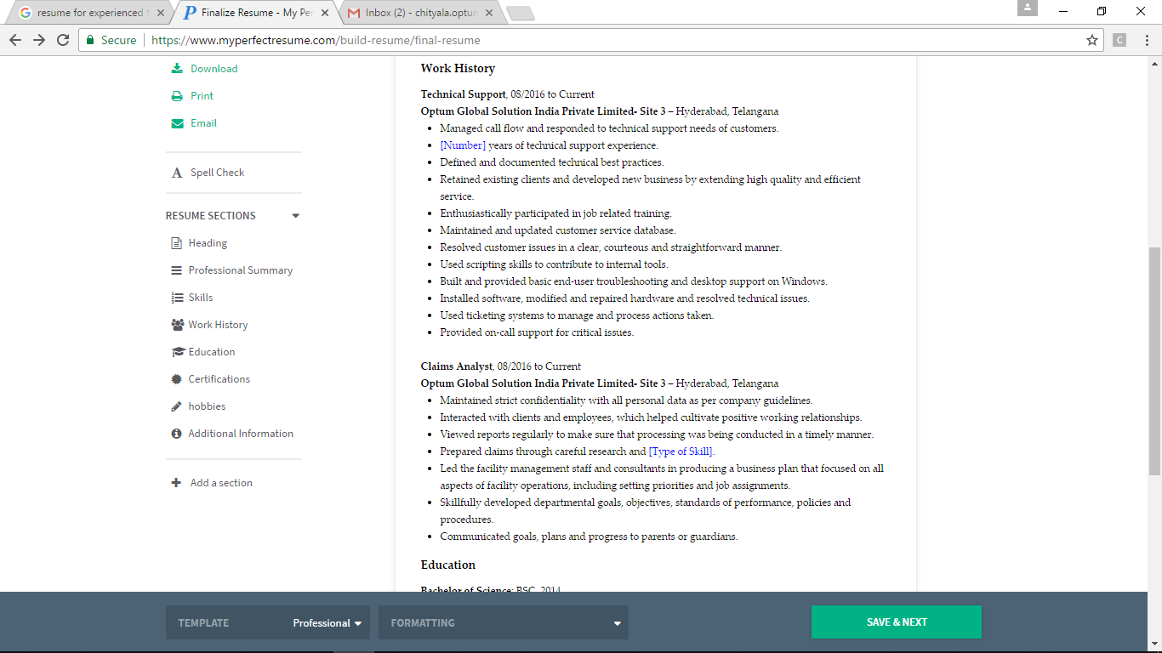

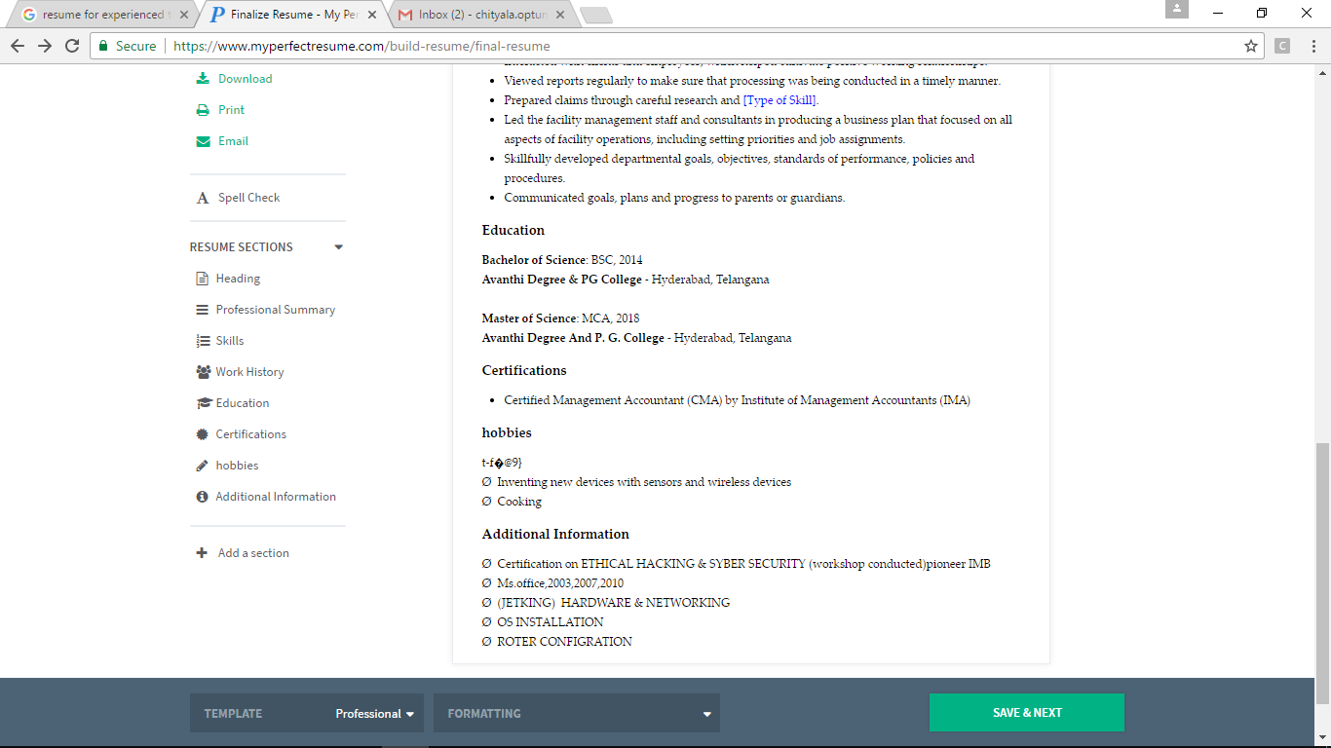

Chityala.vinaykumar 🕿+917981762502

🖂:**[vinaykumar.chityala9@gmail.com](mailto:vinaykumar.chityala9@gmail.com)**

🖂: kumar_chityala@optum.com

**Objective:**

To be associated with a progressive organization, where my skills are utilized and give me scope to update my knowledge in accordance with latest trends and be a part of team that dynamically works towards the organization and thus improve my leadership qualities, innovative skills and analytical capabilities while helping the company to attain its goals.

***Professional Summary:***

Over 2+years experience in Claims associate at Optum global solution’s (“UnitedHealth Group”)

**TECHNICAL SKILLS:**

* Certification on ETHICAL HACKING & SYBER SECURITY (workshop conducted)pioneer IMB
* Ms.office,2003,2007,2010
* (JETKING) HARDWARE & NETWORKING
* OS INSTALLATION
* ROTER CONFIGRATION

**EXPRIANCE:**

I have 2.5 years of experience in UnitedHealth Group

Worked as Claims associate at Optum global solution’s(“UnitedHealth Group”)

**Applications I work**; - NDB PROBASE NICE

Designation:-claims associate “Auditing”

I am with the process about “2 years” as a percent Employee.

Hand full experience in with Outlook 2010

**Academic Credentials:**

**MCA** from AVANTHI PG of College (hyd), Affiliated to OU,. (Completion Year: 2018 )

**Subjects of Interest:**

* COMPUTERS

**Personal Skills:**

.

* Confidence, which enable to active what I can desire, zeal to learn new things, I can manage things in tough time lag
* Adaptability to the situation

**Hobbies:**

* Inventing new devices with sensors and wireless devices
* Cooking

**Personal Profile:**

Date of Birth : 24-12-1992

Father’s Name : Ch.Satyanarayana

Nationality : Indian

Religion : Hindu

Languages : English, Hindi & Telugu

Address : H: NO: 12-11-987,

Boudhanagar, Warasiguda, Secunderabad.

**Declaration:**

I hereby declare that the above mentioned information is true to the best of my knowledge and belief.

**Place:** Hyderabad **(chityala.vinaykumar)**